ALLERGY SAFETY & MANAGEMENT POLICY

ALLERGY SAFETY & MANAGEMENT POLICY

CONTENTS

1.0 POLICY STATEMENT 3
2.0 LEGAL & POLICY FRAMEWORK 3
3.0 CONTEXT 4
4.0 PRINCIPLES 5
5.0 RESPONSIBILITIES 5
6.0 SUPPLY, STORAGE AND CARE OF MEDICATION 10
7.0 CATERING 12
8.0 ALLERGY AWARENESS 14
9.0 RISK ASSESSMENTS 14
10.0 SERIOUS INCIDENTS AND NEAR MISSES 15
11.0 TRAINING 15
12.0 ALLERGIES AND BULLYING 16
13.0 MENTAL HEALTH & WELLBEING 16
14.0 USEFUL RESOURCES 16
Appendix A - Types of Plans 18
Appendix B - Flowchart For Allergic Reaction Without Use of AAI 20
Appendix C - Flowchart For Allergic Reaction With Use Of AAI 21
Appendix D - Information On Allergies 22
Appendix E - Allergy Management Safety Checklist 23

Terminology

- “Our teams” and” “team member/s” include everyone working in Outcomes First Group’s settings and services in a paid or unpaid capacity, including employees, consultants, agency staff, trainees and contractors. For Blenheim schools, volunteers are included in this definition.

- “Parents and carers” refer to the person or -people with legal parental responsibility for the child/young person
- “Students” refers to all children and young people being educated and supported at the setting or service
KEY CONTACTS

All team members who work directly or indirectly with children and young people in our schools and colleges have a responsibility to help keep them safe. The following people have specific additional responsibilities with regard to supporting the safe management of students who live with allergies:

Allergy Safety Lead: Jonathan Walker
Catering Manager/ Lead Paul Robson
Medical team members Michelle Johnston
Designated Safeguarding Lead (DSL): Jessica Wilson; Rochelle Sowden & Charlotte Holgate
Headteacher/Principal: Jo Savage/ David Glaves
Governor/Regional Director/Operations Director: Justine Sims

1.0 POLICY STATEMENT

We are committed to promoting a whole school/college approach to health care, welfare and wellbeing, which includes the safe management of students who live with specific allergies. Allergies are always taken seriously and dealt with in a professional and appropriate way. We will work proactively to:

- minimise the risk of exposure within the school/college setting
- encourage self-responsibility (where possible and appropriate)
- learn avoidance strategies
- have robust plans for an effective response to possible emergencies
- ensure inclusivity for all students
Our school/college is committed to actively supporting students with medical conditions to participate in school/college life. The setting will consider what reasonable adjustments need to be made to enable students with medical conditions to participate fully and safely in all aspects of school/college life.

We recognise that effective allergy management is an important aspect of safeguarding, health & safety, wellbeing and inclusion. We are committed to ensuring that students with allergies feel safe, supported, listened to and included in all aspects of school/college life. We will take all reasonable steps to identify, assess and manage risks associated with allergies and will work in partnership with students, parents/carers, healthcare professionals, catering providers and relevant agencies to keep children safe.

In line with Keeping children safe in education (KCSiE 2026), any deliberate exposure of a student to an allergen, allergy-related bullying, repeatedly failing to follow an Individual Healthcare Plan (IHP) or any concern that a student's allergy needs are not being appropriately will be considered as a safeguarding concern and will be managed in accordance with the Safeguarding Policy, and where relevant the Behaviour Policy, Anti-Bullying Policy and Disciplinary Policy.

2.0 LEGAL & POLICY FRAMEWORK

Schools/colleges have a legal duty to support students with medical conditions, including allergies. This policy has been developed with regard to legislation and government guidance, including:
- Children and Families Act 2014 (Section 100)
- Equality Act 2010
- Health and Safety at Work etc. Act 1974
- Allergy Safety in Schools Statutory Guidance (DfE, July 2026)
- Allergy guidance for schools (DfE, updated July 2026)
- Supporting pupils with medical conditions at school
- Supporting learners with Health Needs (Welsh Government)
- Supporting children & young people with healthcare needs in schools (Scotland)
- Guidance on the use of adrenaline auto-injectors in schools (England)
- Guidance on the use of emergency adrenaline auto injectors in schools in Wales
- Reporting of Injuries, Diseases and Dangerous Occurrences Regulations (RIDDOR)
- The Food Information Regulations 2014
- SEND code of practice: 0 to 25 years - GOV.UK
- Keeping children safe in education (KCSiE 2026)
- Early Years Foundation Stage nutrition
- SEND code of practice: 0 to 25 years - GOV.UK

This policy will be implemented alongside the following:
- Safeguarding Policy
- Medicines Policy and Procedures
- First Aid Policy
- Health & Safety Policy
- Head Injury & Concussion Policy
- Infection Control Policy
- Educational Visits Policy
- Behaviour Policy
- Anti-bullying Policy
- Food Safety Policy
- Food Safety Management Controls

All Outcomes First Group settings in the UK are expected to implement allergy arrangements that meet or exceed the standards outlined within the guidance.

3.0 CONTEXT

The prevalence and complexity of allergic conditions have increased over recent decades. It is estimated that around 40% of children experience at least one allergic symptom or related condition, including allergies to foods, insect stings, medicines, latex and environmental allergens such as pollen, mould and dust mites. Approximately two children in every classroom live with a food allergy. As a result, schools and colleges are increasingly required to support students with a wide range of allergic conditions and associated medical needs.

Schools and colleges must have robust allergy management arrangements, risk management processes, training and emergency response procedures in place to help keep students safe and ensure they are able to participate in all aspects of school/college life.

Whilst most allergies are not fatal, many different types of allergies have the potential to cause anaphylaxis, which is a severe, life-threatening allergic reaction.

The allergies most commonly associated with fatal or near-fatal anaphylaxis include:

- Food allergies (particularly nuts, peanuts, milk, egg, fish and shellfish)
- Insect sting allergies (such as bee and wasp stings)
- Medication allergies (for example, some antibiotics)
- Latex allergy

Some 5-8% of children and young people in the UK are known to live with a food allergy, with around 20% of severe allergic reactions to food happening whilst they are at school and these reactions can occur in students with no prior history of food allergy. It is essential that team members are aware of and recognise the signs of an allergic reaction and symptoms, and are able to manage it safely and effectively.

4.0 PRINCIPLES

Our schools and colleges work in line with the following principles to keep our students as safe and healthy as possible:

- Comply with all relevant legislation, regulations and requirements.
- Encourage proactive steps to keep students safe.
- Ensure students from diverse backgrounds, ethnicities or different cultural heritages and those for whom English is an additional language, are not disadvantaged when dealing with allergies and food labelling.
- Ensure students with Special Educational Needs and Disabilities (SEND) are not disadvantaged when dealing with allergies and food labelling.
- Ensure students with allergies are able to participate fully in school/college life making reasonable adjustments where required.

- Work with the catering provider/team to establish a robust process and documentation for menu planning, food labelling, storing, avoidance of cross-contamination, stock ordering of food/drink used at the setting.
- Provide effective training for team members on allergies, intolerances, symptom recognition and action to take.
- Provide a student awareness programme through RSHE and other curriculum areas.
- Actively involve students and parents/carers in the review and improvement of allergy management arrangements.
- Ensure serious incidents and near misses are reviewed and used to improve practice and reduce future risk.
- Promote a whole-school/college culture of allergy awareness, inclusion and shared responsibility.

5.0 RESPONSIBILITIES

5.1. Governors / Regional Directors/Operational Directors

- Ensure the school/college has a clear plan for the management of allergy risk assessment and emergency procedures
- Delegate the day-to-day responsibility for the effective delivery of this policy to the Headteacher/Principal and ensure that they have appointed a named member of the senior leadership team to be responsible for allergy safety.
- Ensure the setting’s arrangements to identify and safeguard the wellbeing of students, because of their own or someone else’s allergy, are robust and effective
- Ensure that appropriate training, information, instruction, induction and supervision are provided to team members on a regular basis to enable everyone to stay safe regarding allergies and their management.
- Ensure adequate resources for managing allergies are available
- Ensure appropriate material is available on the school/college website for parent/carers, highlighting how the setting is managing students with allergies
- Monitor the setting’s implementation of this policy
- Ensure the school/college:
- completes an annual Allergy Management Review
- completes and records the required information on Info Exchange (e.g. ‘Monthly AAi Audit’ and a ‘Quarterly Allergy and Anaphylaxis Drill’
- implements any actions for improvement as part of a cycle of continuous improvement

5.2 Headteacher/Principal

- Provide, as far as practicable, a safe and healthy environment in which students at risk of allergic reaction and anaphylaxis can participate equally in all aspects of school/college life and are not subject to bullying because of their condition
- Ensure all team members are aware of the school/college’s commitment and approach to allergy management
- Appoint a named member of the senior leadership team in the setting to have overall responsibility for allergy safety (Allergy Safety Lead)
- Ensure the curriculum contains age-appropriate content to raise students’ awareness and understanding of allergies and how they can support people with allergies
- Create effective links with healthcare professionals and catering providers
- Ensure that up-to-date allergy information for students is accessible to catering teams and that best practice in the labelling of foodstuffs and their contents is in place.
- Ensure there is a workable School/College Emergency Plan in place that is known by all team members
- Communicate to parents/carers the importance of informing the school/college of any changes in medical information as soon as possible. Ensure the school/college sends a copy of the medical details it holds for the student to parents/carers for review and update at the beginning of each academic year and at the beginning of each calendar year.
- Where the student has an Individual Healthcare Plan (IHP), ensure the involvement of healthcare and welfare professionals, teaching and catering team members, parents/carers and the student in establishing IHPs
- Encourage parents/carers to provide Allergy Action Plans (AAPs), completed and signed by a healthcare professional, that can be kept with their medication with copies made available for all team members who may need them to access to help them support the student
- Ensure student documentation and information is up-to-date and recorded on the school’s electronic recording system and that in-date medication is kept correctly and safely
- Ensure effective communication of individual student’s medical needs to all team members and that they know how and where to check for updated information.
- Ensure there are enough trained team members to meet the statutory requirements and assessed needs, allowing for absences away from the school/college premises
- Ensure First Aid training includes anaphylaxis management, including awareness of triggers, anaphylaxis and first aid emergency procedures

- Ensure an adequate risk assessment is undertaken prior to any school/college trips, excursions or off-site extra curricula activities for students who have allergies. (A ‘Trip Leader Checklist’ is available on SharePoint to help ensure all requirements are in place.)
- Report to the Board of Governors regarding the management of allergies within the school/college
- Ensure that drills are carried out at least every 3 months to test out emergency allergy arrangements through scenario exercises and /or tabletop exercises the drills are recorded on Info Exchange
any concerns arising from the drills are resolved as a matter of urgency.
- Ensure allergy management is reviewed regularly through monitoring, audits (e.g. Monthly AAi Audit), serious incident reviews and an annual Allergy Management Review.
- Ensure the required information is reported on Info Exchange and implement any actions for improvement as part of a cycle of continuous improvement

5.3 Allergy Safety Lead

- Follow all legal requirements, recommended best practice and school/college policies and procedures pertaining to allergies and related matters.
- Report to the Headteacher/Principal regarding students with allergies
- Ensure that team members are trained regarding allergy medical needs and their identification and management
- Work closely with in-house and sub-contracted Catering Managers in assisting the support of students with known allergies (including meeting with parents/carers where requested) to discuss any special requirements
- Monitor where there is a school/college ‘tuck shop’ or home baked items are brought into school
- Liaise with parents/carers of students with known declared allergies to produce a risk assessment for their child that includes sharing of information, allergy management, risk minimisation and emergency actions.
- Wherever possible use an AAP for students with recognised allergies and keep it with their medication. Ensure copies of the AAP are available for all team members to access.
- Where an AAP has not been received for a student with recognised allergies, or if the medication information is not clear, liaise with GP, to obtain an up-to-date copy and/ or clarification.
- If an additional written IHP is not required, ensure that the AAP is viewed and treated with the same level of seriousness.
- Ensure all copies of the AAP/IHP located around the site and/or on IT systems are identical if an updated version is received.

- Ensure allergy medication is stored appropriately and that the school/college has a spare supply of in-date AAIs in line with the risk assessment and that they are in correct condition. (Please see Sections 6.1 and 9.0)
- Monitor the use of all AAIs and ensure they are within the expiry date including those brought into the school/college by students or external sources and are of the correct dosage
- Arrange for the correct disposal of out-of-date AAIs and other allergy medication.
- Be trained in the use of AAIs and be competent in performing required prescribed medical treatment as outlined in the student’s IHP and/or AAP
- Ensure that other team members involved with students requiring the use of an AAI are also adequately trained and competent
- Ensure all school/college trips, excursions or off-site extra curricula activities for students are pre-checked so that ‘safe’ food is provided or that an effective control is in place to minimise risk of exposure for students with allergies
- Where anaphylaxis is suspected in an undiagnosed individual, call the emergency services and state “ANAPHYLAXIS is suspected”, then follow their advice as to whether administration of a spare AAI is appropriate
- Record all emergency uses of AAIs or reports of suspected emergencies in line with the Medicines Policy and First Aid Policy.
- Ensure that, if a student notifies school/college that they are no longer allergic to a food, this information is checked prior to updating records and the IHP (if applicable).
- Maintain an Allergy Register identifying all students with allergies, their allergens, location of medication and required emergency treatment. The register will be reviewed regularly and updated whenever new information is received.
- Ensure the following information is documented and kept up-to-date:
- allergy training completed
- allergy medication checks including expiry date monitoring
- incidents and near misses
- emergency use of AAIs

5.4 All Team Members

- Follow as directed all the requirements of the school/college policies and procedures pertaining to allergies
- Complete allergy awareness training appropriate to their role and understand how to access emergency support, healthcare plans and emergency medication
- Raise awareness about allergies and anaphylaxis amongst their students in the classroom and around the school/college, especially in dining areas

- Encourage self-responsibility and learned avoidance strategies amongst students living with allergies
- Help all students understand which foods are safe for those with food allergies, that not all allergies are food related, and how they can support other students with allergies to stay safe
- Highlight the need for anti-bullying of students with the condition
- Be aware of the students in their care (including regular cover classes) who have known allergies, and be aware that an allergic reaction could occur at any time, not just at breaks or mealtimes
- Any food-related activities must be supervised with due caution whilst following best practice for storing, preparing, cooking and serving food
- Team members leading a trip, excursion or other off-site activity must ensure that students with medical conditions, including allergies, have immediate access to their prescribed medication, either by carrying it themselves or through an identified team member, in accordance with the risk assessment. If a student does not have their required medication, the trip leader must carry out an immediate risk assessment to determine whether it is safe for them to participate. Where safe participation cannot be assured, the student may be unable to take part.

5.5 Parents/Carers

- Notify the school/college of any allergies their child has and inform the school/college of any changes as soon as known
- Talk with your child about allergy self-management, including what foods, substances or items are safe and unsafe, how to read food labels, strategies for avoiding allergens, how to spot symptoms of allergy, how and when to tell an adult if experiencing an allergic reaction.
- Provide an AAP completed by a healthcare professional that can be kept with their medication and help the school /college support the student
- Contribute to the provision of an IHP in partnership with the school/college, and relevant healthcare professional, where required.
- Provide any other written medical documentation, instructions and medications as directed by a health professional.
- If required, meet with the Catering Manager to discuss any specific requirements relating to your child’s allergy (information from these meetings will be recorded by the Catering Manager and kept on the child’s record on the school’s electronic recording system)
- Be aware of the Allergy Policy and any arrangements for managing students with allergies and at risk of anaphylaxis
- Inform the school if their child as ever experienced biphasic anaphylaxis i.e. a second phase of an anaphylactic reaction occurring after initial symptoms have improved or resolved, without any further exposure to the allergen
- Communicate regularly with the school/college to support our ability to keep your children safe and act immediately in the event of an allergic reaction
- Provide appropriate in date medication (two AAIs, if they are prescribed AAIs) of the correct dosage and register any AAIs on the manufacturer’s websites to receive text alerts for expiry dates
- Replace medications after use or upon expiry
- Provide appropriate foods to be consumed by the child/young person if necessary
- Review the policy and procedures with the Head/Principal and/or Allergy Safety Lead, the student’s doctor and the student (if appropriate) after a reaction has occurred

5.6 Students with Allergies (as age and developmentally appropriate)

- Have a good awareness of their allergy and, if they are able and feel comfortable to do so, inform other students of their allergies and how it affects them.
- Be proactive in the care and management of their allergies, reactions and medication where possible
- Be sure not to exchange food with others and take care to avoid any foods, substances or items which may cause an allergic reaction
- Read food labelling but, if unsure, avoid the food - avoid consuming anything with unknown ingredients
- Know where their medication is kept and (if age/developmentally appropriate and confident enough to administer their own AAIs)take responsibility for carrying AAIs on their person at all times
- As soon as they suspect they are experiencing signs of allergic reaction, tell an adult.
- If a student with an allergy is unable to understand their plan, then a capacity assessment and best interests assessment will be arranged.
- Where a student refuses to follow their plan, a Gillick Competency will be considered as part of the capacity assessment

All Students

Students will be supported to understand allergies, recognise risks, seek help appropriately and contribute positively to an inclusive environment. Age-appropriate allergy education will form part of the setting’s wider programme of health education, wellbeing, safeguarding and anti-bullying work and will be included in RHSE and other curriculum areas.
Where a student has an allergy that affects daily school/college life, team members will ensure that classmates understand any necessary safety arrangements in a manner that protects the students dignity and confidentiality.

6.0 SUPPLY, STORAGE AND CARE OF MEDICATION

Where age and developmentally appropriate, students should be encouraged to take responsibility for carrying their medication, including their AAIs (where appropriate), with them at all times in a suitable bag or container. However, because anaphylaxis can develop suddenly, team members must be ready to administer medication if the student is unable to do so.

For younger children or those not ready or able to take responsibility for their own medication, their allergy medication will be kept safely in accessible location/s that are accessible to all team members in line with the risk assessment. Allergy medication must not be locked away.

Allergy medication should be stored in a suitable container and clearly labelled with the student’s name and a photograph. Each student known to be at risk of anaphylaxis must have a medication storage container that contains:
- Two AAIs i.e. EpiPen® or Jext® (where required)
- An up-to-date allergy action plan
- Antihistamine tablets or syrup (if included on allergy action plan)
- Spoon/ dispenser/dropper/oral syringe if required
- Asthma inhaler (if included on allergy action plan)

It is the responsibility of the parents/carers to ensure that allergy medicine and anaphylaxis kits required for their child are up-to-date and clearly labelled. The Allergy Safety Lead will check medication kept at school/college on a termly basis and send a reminder to parents/carers if medication is approaching expiry.

Parents/Carers can subscribe to expiry alerts for the relevant AAIs their child is prescribed, to make sure they can get replacement devices in good time. For further information, please see: Adrenaline Auto-Injector Expiry Dates

6.1 Spare AAIs

The school/college will maintain an adequate supply of spare, in-date adrenaline auto-injectors (AAIs), in line with the setting’s risk assessment, taking account of the number of students at risk of anaphylaxis, their ages and prescribed doses, weight and the size and layout of the site, in line with the Department of Health and Social Care’s Using emergency adrenaline auto-injectors in schools.
The school/college is responsible for purchasing the required number of spare AAIs and ensuring they are up-to-date and communicating the location of spare AAIs to all relevant team members. This will be organised by the Allergy Safety Lead.
Spare AAIs must be kept at room temperature (between 15°C to 25°C), protected from direct sunlight and temperature extremes, in clearly identified locations in line with the school/college risk assessment. The identified locations must be safe and secure but AAIs must not be locked away. All team members must be aware of the location/s.
The setting will maintain a register of AAIs held at the site and will check the AAIs at least termly. AAIs must be replaced promptly following use or expiry.

Spare AAIs are intended to provide emergency treatment for students at risk of anaphylaxis where their prescribed device is unavailable, inaccessible, damaged or fails to operate correctly.
Where anaphylaxis is suspected in an undiagnosed individual, emergency services should be called and state “ANAPHYLAXIS is suspected”, then follow their advice as to whether administration of a spare AAI is appropriate

6.2 Expiry Monitoring

The school/college will maintain a documented system for checking expiry dates of all allergy medication and spare AAIs. Medication checks will take place at least termly and more frequently where required. Parents/carers will be notified when medication is approaching expiry.
6.3 Disposal

Medicines must be disposed of in line with the Medicines Policy.

AAIs are single use only and must be disposed of as sharps. Used AAIs can be given to ambulance paramedics on arrival or can be disposed of in a pre-ordered sharps bin. Sharps bins to be obtained from and disposed of by a specialist collection service.

The sharps bin is kept in the following room: Health Care Practiotioner’s Office

6.4 Medication Audits

The school/college will retain records of medication checks, replacement requests and actions taken. These records will form part of the school's allergy audit arrangements.

7.0 CATERING

All food businesses, including school/college caterers, must follow the Food Information Regulations 2014 which states that allergen information relating to the ‘Top 14’ allergens must be available for all food products.

The school/college and catering provider will ensure that allergen information remains accurate whenever menus, suppliers or ingredients change. Particular attention will be paid to foods that are pre-packed for direct sale (PPDS). Appropriate allergen labelling will be maintained in accordance with current food information requirements.

The school/college menu is available for parents/carers to view, weekly, in advance with all ingredients listed and allergens highlighted on ISAMs.

The Allergy Safety Lead will inform the Catering Manager of students with food allergies.

The school/college has the following system in place to ensure catering team members can identify students with allergies The School Heath Care Practitioner develops individual health care plans that are followed by Kitchen and Education Staff. Education staff support students closely and have risk assessment for each individual. Kitchen staff are made aware of the students who have allergies and what these are, as instructed by the Health Care Practitioner.

Parents/carers are encouraged to meet with the Catering Manager to discuss their child’s needs.

The school/college adheres to the School food standards: resources for schools including:
- Bottles, other drinks and lunch boxes provided by parents/carers for students with food allergies should be clearly labelled with the name of the child for whom they are intended.
- If food is purchased from the school/college canteen/tuck shop, parents/carers should check the appropriateness of foods by speaking directly to the catering manager.
- The student should be taught to also check with catering team members, before purchasing food or selecting their lunch choice (where practicable).
- Where food is provided by the school/college, team members should be educated about how to read labels for food allergens and instructed about measures to prevent cross-contamination during the handling, preparation and serving of food. Examples include: preparing food for students with food allergies first; careful cleaning (using warm soapy water) of food preparation areas and utensils. For further information, parents/carers are encouraged to liaise with the school/college.
- Food should not be given to primary school age food-allergic children without parental/carer engagement and permission (e.g. birthday parties, food treats).
- Use of food in crafts, cooking classes, science experiments and special events (e.g. fetes, assemblies, cultural events) needs to be considered and may need to be restricted/risk assessed depending on the allergies of particular children/young people and their age.

8.0 ALLERGY AWARENESS

The school/college adopts an allergy-aware approach rather than describing itself as allergen-free, as we recognise that no environment can be guaranteed to be completely free from allergens and therefore do not rely solely on blanket food bans to manage risk.

Where an individual’s risk assessment indicates that specific restrictions are necessary to reduce risk, proportionate and reasonable adjustments may be introduced. These decisions will be based upon risk assessment, healthcare advice and individual student needs.
The school/college promotes a culture of allergy awareness, education, personal responsibility and collective support.

9.0 RISK ASSESSMENTS

9.1 Site-specific Allergy Risk Assessment

The school/college will maintain a site-specific allergy risk assessment which will be reviewed at least annually and whenever a significant change occurs. The assessment will identify foreseeable allergy risks, control measures, emergency response arrangements and the location and quantity of spare AAIs required across the site. Spare AAIs will be placed in locations determined by the risk assessment to ensure they can be accessed rapidly in an emergency.
A risk assessment template can be found on SharePoint.
9.2 Individual Risk Assessments

Individual allergy risk assessments must be in place for all students known to have allergies and reviewed regularly to ensure they remain accurate and effective. The assessment will identify any risks, gaps in systems or procedures, and any control measures required to keep the student safe.

A risk assessment template can be found on SharePoint and will be completed:

• when a student joins the school;
• following diagnosis of a new allergy;
• following any serious reaction;
• where circumstances change;
• before educational visits, residential visits, work experience placements, alternative provision and off-site activities

Risk assessments must be reviewed at least annually.

10.0 SERIOUS INCIDENTS AND NEAR MISSES

A serious incident is an incident, event or circumstance that causes or could cause significant/serious harm to the health, safety or well-being of a student (s) or other people. Serious incidents may also be related to a team member(s) and the incident could have occurred either in or out of the school or college setting.
A near miss is an event that could have caused an allergic reaction but did not. For example, a student is given the wrong meal, but it is noticed before they eat it.
All allergy-related incidents, emergency medication administration, near misses and accidental allergen exposures will be recorded including the:
date, time and location of the incident

- allergen involved (If known)
- signs and symptoms observed
- Actions taken, including any medication administered and if emergency services were contacted.
- outcome of the incident
- names of the team members involved and any witnesses

Following any serious incident or near miss, the school/college will inform parents/carers and undertake a structured review to identify:
• contributory factors;
• lessons learned;
• required improvements;
• additional training needs;
• amendments to risk assessments, IHPs or procedures.

Actions identified through reviews will be documented and monitored to completion.

The Serious Incident Notification Policy sets out the expectations of the internal process for notifying serious incidents to senior leaders and the Executive Team and must also be followed.

11.0 TRAINING

All team members will receive allergy awareness training appropriate to their role. Those who may be required to support students during an allergic reaction will receive practical training in the recognition and treatment of anaphylaxis, including the use of AAIs.
Training will form part of team member induction and will be refreshed at appropriate intervals. Training records will be maintained by the school/college.

Training is organised by the Learning & Development department. Team members will be sent details to log in and complete the required training, which includes a basic understanding of allergic disease and its risks which include:
- Knowing the common allergens and triggers of allergy
- Spotting the signs and symptoms of an allergic reaction and anaphylaxis. Early recognition of symptoms is key, including knowing when to call for emergency services
- Administering emergency treatment (including AAIs) in the event of anaphylaxis
knowing how and when to administer the medication/device
- Measures to reduce the risk of a child having an allergic reaction e.g. allergen avoidance
- Knowing who is responsible for what
- Associated conditions e.g. asthma
- Managing Allergy Action Plans and ensuring these are up to date

At least every three months, drills will take place to practice the emergency allergy arrangements using scenario exercises and/or tabletop exercises and must be recorded on Info Exchange with any concerns arising from the drills being resolved as a matter of urgency.

12.0 ALLERGIES AND BULLYING

Please also see the Behaviour Policy and Anti Bullying Policy.

Any bullying related to a student’s allergy will be treated seriously, like any other bullying. We aim to ensure that all students with medical conditions, in terms of both physical and mental health, are properly supported in school/college so that they can play a full and active role in school/college life, remain healthy and achieve their potential.

Deliberately exposing a student to an allergen, threatening to expose a student to an allergen, tampering with medication or healthcare arrangements, or using a student’s allergy as a means of intimidation will be treated as a serious behavioural and safeguarding concern.

13.0 MENTAL HEALTH & WELLBEING

Living with an allergy can have a significant emotional impact on some students. Concerns about accidental exposure to an allergen, experiencing an allergic reaction, or feeling different from their peers may lead to worry or anxiety. Signs that a student may be experiencing anxiety related to their allergy can include:

• excessive concern about allergens
• frequent reassurance-seeking
• repeated handwashing
• avoiding activities or social situations due to fear of allergen exposure,
• unnecessarily restricting foods that they are not known to be allergic to
Schools and colleges should be aware of the potential emotional impact of allergies and provide appropriate support, reassurance and encouragement to help students participate fully and safely in school life.

14.0 USEFUL RESOURCES

British Society for Allergy & Clinical Immunology (BSACI)- resources asset for schools and parents.
Allergy School and The Natasha Allergy Research Foundation
Allergy UK Helpline: providing support, advice and information for those living with allergic disease tel. weekdays 9am-5pm 01322 619898
FSA reporting tool for allergies
Living with Serious Allergies | Anaphylaxis UK

Appendix A – Types of Plans

A.1 Allergy Action Plan (AAP)

This type of plan is primarily a clinical document that should normally be completed and authorised by an appropriate healthcare professional, such as the student's GP, allergy consultant, paediatrician or specialist allergy nurse.

The AAP provides the medical instructions that school/college team members should follow in the event of an allergic reaction. It should include:

• The student's full name, date of birth and photograph
• Details of the student's diagnosed allergy, allergies and any related conditions, including known allergens and triggers
• A description of the signs and symptoms to look out for
• Clear step-by-step instructions on what action to take in the event of an allergic reaction
• Details of any prescribed medication, including antihistamines and adrenaline auto-injectors (AAIs), including dosage and brand, where applicable.
• Instructions on when and how to administer medication
• Any additional clinical instructions
• The name, signature and date of the healthcare professional completing the plan
• The student’s emergency contacts (at least two, where possible)
• Parent/carer and confirmation that the school may follow the plan in an emergency

One copy of a student’s AAP should be placed with their medication and another shared with all team members. Each term, the Allergy Safety Lead should use this document to practice the school/college’s emergency response.

It is recommended that the AAP be reviewed whenever there is a change in diagnosis, medication, allergy status, emergency treatment requirements, or following a significant allergic reaction, and at least annually as part of the student's healthcare planning arrangements.

A.2 Individual Healthcare Plan (IHP)

This type of plan sets out how the school/college will support a student with a medical condition, including allergies, during their time at the setting. The purpose of the IHP is to ensure that everyone involved understands the student’s medical needs, how risks will be managed, and what actions must be taken in an emergency.

It should be written in collaboration between the school/college, the student (where age, understanding and capacity allow), the student’s parents/ carers and any relevant healthcare professional/s.

It should include:
• the student's name, date of birth and photograph.
• Details of the medical condition or allergy, including known allergens and triggers.
• Signs and symptoms of an allergic reaction and anaphylaxis.
• Medication required, including the type, dosage, location and instructions for administration.
• Clear emergency procedures, including when to administer medication and when to call emergency services.
• Details of any Allergy Action Plan (AAP) and how it links to the IHP.
• Day-to-day management arrangements and reasonable adjustments.
• Individual control measures and risk reduction strategies.
• Arrangements for trips, visits, sports and other activities.
• Key contacts, including parents/carers, healthcare professionals and emergency contact numbers.
• The roles and responsibilities of team members involved in supporting the student.
• Review dates and arrangements for updating the plan.

The school/college must then obtain written confirmation that the student’s parents/carers are happy with the plan.

Appendix B - Flowchart For Allergic Reaction Without Use of AAI
Refer to the child/young person’s BSACI Allergy Action Plan if they have one and call for other team members’ help if needed

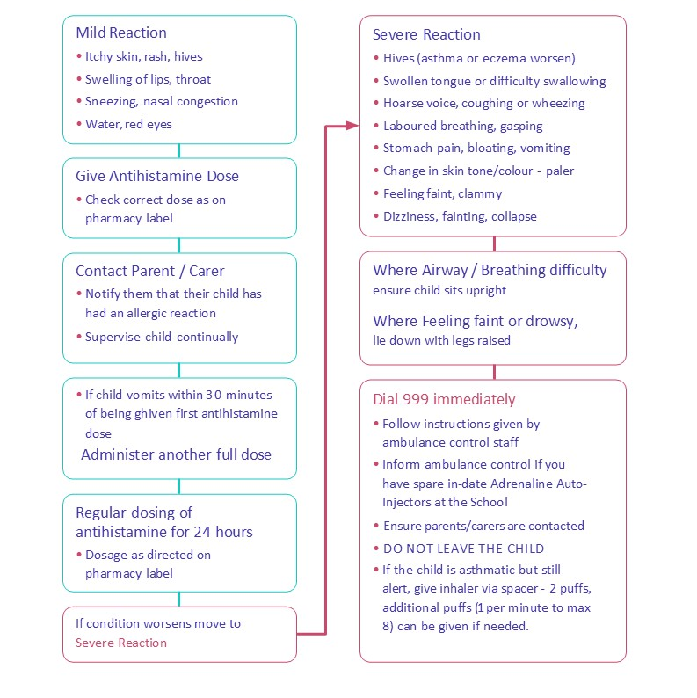

Appendix C - Flowchart For Allergic Reaction With Use Of AAI
Refer to the child/young person’s BSACI Allergy Action Plan if they have one and call for other team members help if needed
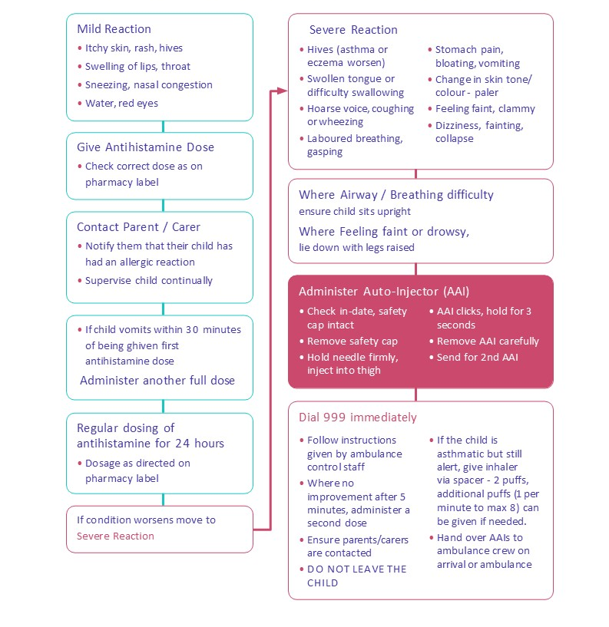

Appendix D - Information On Allergies
The most fourteen most common causes of food allergens as identified in The Food Information Regulations 2014 are:
- Cereals containing Gluten | - Nuts
- Celery | - Peanuts
- Crustaceans | - Mustard
- Eggs | - Sesame Seeds
- Fish | - Sulphur dioxide/Sulphites
- Soya | - Lupin
- Milk | - Molluscs

However, it is possible that any food has the potential to cause an allergic reaction. Contact with any food or materials containing a child’s allergen has the potential to cause an allergic reaction for that child.
Latex, chemicals, medicines, grasses, pollen, weeds, trees, pets, insect venom and animal dander (shredded flakes of skin) can also cause allergic reactions.

Symptoms
Mild to moderate symptoms include:
    - Swelling of the eyes, face and lips
    - Runny or congested nose
    - Raised itchy rash (hives), eczema flare, skin flushing
    - Itchy mouth
    - Stomach cramps, nausea, vomiting, diarrhea

Severe symptoms include:
    - Swollen tongue, hoarse voice or cry, difficulty swallowing and talking
    - Chest tightness
    - Breathing difficulties, persistent cough, wheeze
    - Low blood pressure, feeling faint, collapse
    - Pale and floppy (babies and small children)

Appendix E - Allergy Management Safety Checklist

Allergy Management Requirement | Completed
Each student with a known allergy has an Individual Healthcare Plan and these are regularly reviewed (at least annually) and up-to-date
Each student that has a known allergy has a completed and signed Allergy Action Plan. (Appropriate arrangements are in place for students who are unable to understand their plan) and these are regularly reviewed (at least annually) and up-to-date
An up-to-date Allergy Register is in place identifying all students with allergies, their allergens, location of medication and required emergency treatment. The register is reviewed regularly
The setting has completed an allergy risk assessment

All team members have been trained appropriately in allergy and anaphylaxis
The setting has purchased the appropriate number of spare AAIs in line with the risk assessment
Spare AAIs are stored in the locations identified in the risk assessment and this has been communicated clearly to all relevant team members
There is a schedule to check the expiry dates on spare AAIs and each student’s AAI
Risk assessments are completed for extra curricula trips and activities
Safe catering processes and procedures are in place in line with this policy
Drill exercises have been completed every 3 months and recorded on Info Exchange
Monthly AAi Audits are carried out and recorded on Info Exchange
Incidents and near missies have been reviewed with any improvement actions identified and implemented

