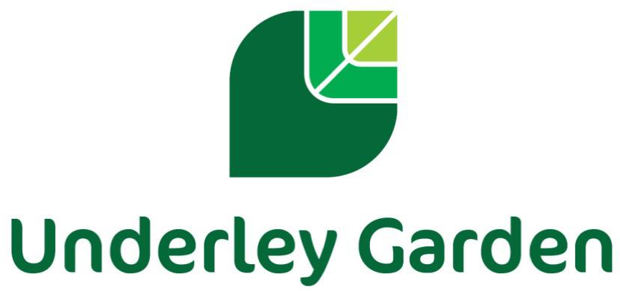

Careers Policy

Created: | 2018
Reviewed by: | Rochelle Sowden (Careers Lead)
Reviewed: | September 2025
To be reviewed: | September 2026

Introduction

Underley Garden School is an independent school providing specialist education for children and young
people aged 5 – 19 with a range of Complex Needs. All of our children and young people have significant barriers to learning due to their complex learning difficulties and disabilities in the area of autistic spectrum conditions, moderate to severe learning difficulties, associated medical and health issues and moderate mental health conditions. All of our young people are extremely vulnerable and many have experienced disruption to formal education.

At Underley Garden School, we believe all young people deserve the right to an education that will
support them to become happy and confident individuals with skills, qualifications and achievements
that will support them in their future. The overriding aim of our curriculum and wider work is to achieve the best possible outcomes for our young people in terms of individual learning, independence, personal growth and development and preparation for the world of work. We believe that a robust Careers program and guidance provides a major contribution in supporting them in choosing appropriate pathways that suit their interests, needs and abilities and help them to follow an appropriate career path and sustain employability throughout their working lives where possible.

At Underley Garden, the Career Development Institute (CDI) framework is the foundation of our Careers curriculum as well as following the Gatsby Benchmarks as part of the DfE Careers Strategy. (See appendix 1 and 2 for more details)

Rationale

Underley Garden offers a broad and balanced curriculum and aims to provide Careers Guidance that:
    - Is accurate and up to date
    - Is presented in an impartial manner
    - Contributes to strategies for raising achievement, especially by increasing motivation and providing access to accreditation pathways
    - Supports inclusion, challenge stereotyping and promote equality of opportunity
    - Develops enterprise and employment skills
    - Contributes to the economic prosperity of individuals and communities
    - Meets the needs of all our young people through appropriate differentiation
    - Focuses on young people on their future aspirations
    - Involves parents and carers

At Underley Garden, we recognise and celebrate that all of our young people are different and as a result, their education and career pathways will be planned on an individualised basis, we use a holistic, person-centred approach to the development of our young people to ensure they achieve the best possible outcomes. Although we follow the CDI framework that is organised into key stages, our Careers curriculum is flexible and key stages are followed depending on the individual needs and main areas of development within that class, as opposed to their age group. We believe careers education should start as early as possible and so we ensure it is incorporated into the curriculum from reception upwards.

Underley Garden aims to maximise the benefits for every young person, supporting them to reach their full potential and give a sense of direction in their future life. The young people will access the possibilities and opportunities available to them in the world of work through work related learning opportunities both onsite and offsite where possible.
We aim to equip our young people with skills for working life by promoting personal development, functional skills and independence skills; which in turn will support to improve motivation and attainment, self-esteem and developing long term realistic aspirations. Thus, preparing them for adulthood and working life.

Student Entitlement

Careers Education and guidance is an important component of the Curriculum and at Underley Garden, we fully support the statutory requirement for a programme of careers education. Young people have access to a careers programme that is delivered as a stand-alone lesson within the weekly timetable for young people following our Daisy, Sunflower and Tulip pathways. For students following our Bluebell and Buttercup pathways, Careers is delivered as part of a thematic approach and is very much individualised to each student’s needs (Please see our curriculum policy for further details of our learning pathways). Our careers curriculum gives young people the opportunity to explore a range of careers possibilities, qualifications routes and learning paths. We hold an annual Careers week, liaising with a wide array of local businesses who deliver employer engagement opportunities and workshops to support our young people’s interests (See our provider access policy). Our young people also have opportunities for 1:1 career meeting with our independent careers advisor, who schedules regular visits to our school. Where appropriate the Careers advisor attends EHCP reviews, Child looked after meetings and Personal educational planning meetings. Young people in KS4 and 5 are given the opportunity to attend off site careers events and college open evenings / events and work skill placements. Transition visits to other training providers are also supported so young people are aware of as many options available to them as possible. Where a student’s next steps is to attend a provision in a different local authority, links will be made at the earliest opportunity with the relevant people and organisations to ensure a smooth transition.

Implementation of Careers Education and advice

Careers education is delivered to all young people and provision is made to allow all young people to access the curriculum at the appropriate level. Young people are encouraged to follow career paths that suit their interests, skills and strengths with the absence of stereotypes. At Underley Garden, the CDI framework is the foundation of our Careers curriculum as well as following the Gatsby Benchmarks as part of the DfE Careers Strategy. There are six learning areas within the CDI framework that can be seen below. These are incorporated into our whole school curriculum map, one area being covered each half term up to key stage 3. From Key stage 3 onwards, Learners will access the ‘Incredible Futures’ Careers curriculum where they complete work towards both the CDI framework and AQA Unit awards.

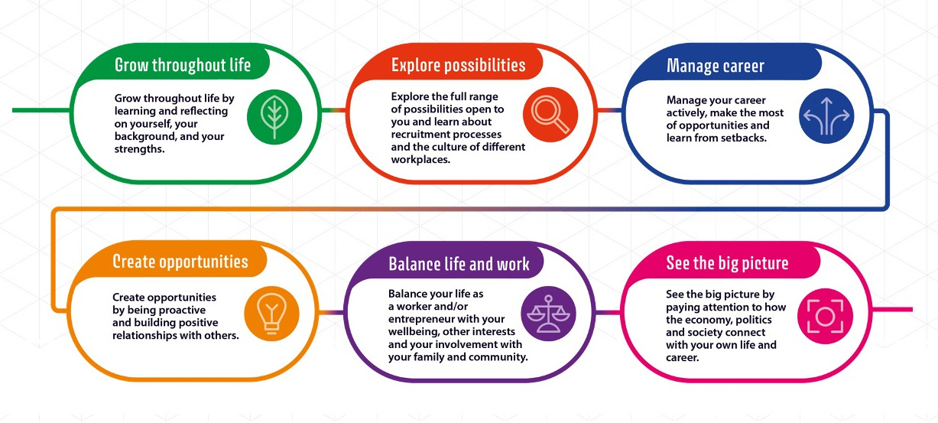

See appendix 2 for more details

The young people at Underley Garden also have access to an allocated Outcomes First Group Futures advisor and, where appropriate, an Independent Careers advisor from Inspira. These advisors support our young people with appropriate and up to date good quality personal guidance with clear links to labour market opportunities.

‘A ‘positive career’ will mean something different to different people, but it will typically include being happy with the way you spend your time, being able to make a contribution to your community and being able to have a decent standard of living’. (CDI framework 2021)

Assessment

Assessment is integral to teaching and learning within Careers and is carried out in accordance with the whole-school policy. We use the CDI Framework to help track our young people’s progress in Careers and identify areas of development. Our assessment is ongoing and is continually captured throughout the school day when our pupils are seen applying their skills and knowledge in real-life situations or to different subjects using Evidence for Learning. The style of assessment used is non-threatening and promotes the young people’s self-esteem. There are clearly defined links between objectives and assessment. The criteria by which the work is to be judged are shared and accessible by the young people, where appropriate. Assessment is continuous and the outcomes of the process are used to inform subsequent teaching. Young people receive regular feedback from their teachers concerning their progress and achievement and this is communicated to parents, carers and associated professionals in termly subject reports and in the statutory annual review documentation.

Post 16

Our Post 16 provision follows the Tulip pathway which offers a semi-formal curriculum with a holistic approach that focuses on developing Independent Life skills, Personal development and Preparing for Adulthood.

We provide a variety of vocational options that have been developed to give learners the opportunity to:
  - Experience more than one vocational sector where they have not yet decided on a specific sector to follow
  - Develop knowledge, understanding and skills of difference vocational sectors to motivate them to progress to higher-level qualifications or employment in a specific sector.
  - Develop cross-cutting employability skills through carrying out practical activities in a vocational context
  - Engage in learning which is relevant to them and provide opportunities to develop a range of skills and techniques, personal skills and attributes essential for successful performance in working life
  - Progress to employment, further education, volunteering or training

Accreditation Opportunities

Careers Education, Personal development and Work Related Learning is well promoted throughout the curriculum and accredited in KS3, KS4 and Post 16; there are several accredited courses including:

- Open Awards Entry level Award, Certificate and Diploma in Skill for further learning and Employment
- Open Awards Entry level Award and Certificate in Independent Living-Looking After Yourself and your Home
- Open Awards Entry level Award and Certificate in Independent Living-Living in the Community
- AQA Unit award Scheme

These courses enable learners to gain knowledge, skills and experience in:
- Developing Self / Self Awareness
- Preparation for Work / Investigating possible career choices
- Financial Capability
- Skills for Employment
- Opportunities for Learning and Work / Engaging with the Careers service
- Keeping safe in the community
- Experiencing the world of work
- Wellbeing
- Making Informed Career Choices
- Employability
- Recognising work areas in the local community

Work Experience

Aim of Work Experience:

- To enable the development and learning of young people
- To provide young people with records/documents to provide evidence of their experience
- To provide young people with direct experience of the world of work
- To give young people the experience of relationships, routines and processes that are part of a working environment
- To develop work related skills
- To contribute towards approved vocational and academic qualifications where necessary
- To prepare young people for adult and working life
- To encourage young people to widen their horizons by viewing work experience as an opportunity to sample non-traditional areas of work
- To prepare young people by discussing equal opportunities
- To make clear the roles and responsibilities of all involved in work experience
- Work experience can provide an excellent opportunity for young people to develop an understanding of what an employer will expect of them and so enhance their employability.
- Various patterns and length of work experience placements need to be flexible to ensure that the learning needs of our young people are met.
- The work will be appropriate to the student’s capabilities.
- There will be an appropriate level of supervision provided throughout the placement.
- Placements are assessed for risks and insurance checked.

Supporting Young People on Work Experience

WORK EXPERIENCE COMMENCES

STUDENT
PLACEMENT

SCHOOL

VISITS BY CAREERS
ADVISOR CO-OPERATE WITH EMPLOYER INDUCTION
SUITABILITY WEAR PROTECTIVE EQUIPMENT SUPERVISION
EXPECTATIONS KEEP A DIARY SAFE ENVIRONMENT
H&S INDUCTION DISCUSS PROGRESS
EMERGENCY CONTACTS
SUPERVISION

EVALUATION

Parents and Carers

Parental involvement is important and encouraged at all stages. Parents / carers are kept up to date with careers related information through Newsletters and our Website. They are also updated during parents’ evenings and within school reports. Regular updates are also given during annual reviews (Inc. EHCP, PEP, and CLA’s) and copies of Career advisor reports discussed and sent home.

Monitoring

The practical application of this policy will be reviewed annually or when the needs arise. If you have any questions or queries with regards to this policy or our Careers curriculum please contact the careers lead on the information below:
Rochelle Sowden
Tel: 01524 271569
Email: rochelle.sowden@underleygarden.org

Appendix 1.

The Gatsby Benchmarks are:

1. A stable careers programme | Every school should have an embedded programme of careers education and guidance that is known and understood by pupils, parents and carers, staff, governors, employers and other agencies. | - Every school should have a stable, structured careers programme that has the explicit backing of governors, the headteacher and the senior management team, and has an identified and appropriately trained careers leader responsible for it.  - The careers programme should be tailored to the needs of pupils, sequenced appropriately, underpinned by learning outcomes and linked to the whole-school development plan. It should also set out how parents and carers will be engaged throughout.  - The careers programme should be published on the school’s website and communicated in ways that enable pupils, parents and carers, staff and employers to access, and understand it.  - The programme should be regularly evaluated using feedback from pupils, parents and carers, teachers and other staff who support pupils, careers advisers and employers to increase its impact.
2.Learning from career and labour market information | All pupils, parents and carers, teachers and staff who support pupils should have access to good-quality, up-to-date information about future pathways, study options and labour market opportunities. Young people with special educational needs and disabilities (SEND) and their parents and carers may require different or additional information. All pupils will need the support of an informed adviser to make the best use of available information. | - During each Key Stage, all pupils should access and use information about careers, pathways and the labour market to inform their own decisions on study options or next steps.  - • Parents and carers should be encouraged and supported to access and use information about careers, pathways and the labour market to inform their support for pupils in their care.
3.Addressing the needs of each young person | Pupils have different careers guidance needs at different stages. Careers programmes should help pupils navigate their concerns about any barriers to career progression. In addition, opportunities should be tailored  to the needs of each pupil, including any  additional needs of vulnerable and  disadvantaged pupils, young people with  SEND and those who are absent. | - A school’s careers programme should actively seek to challenge misconceptions and stereotypical thinking, showcase a diverse range of role models and raise aspirations.  - Schools should keep systematic records of the participation of pupils in all aspects of their careers programme, including the individual advice given to each pupil, and any subsequent agreed decisions.  - For pupils who change schools during the secondary phase, information about participation and the advice given previously should be integrated into a pupil’s records, where this information is made available.  - Records should begin to be kept from the first point of contact or from the point of transition.  - All pupils should have access to these records and use them ahead of any key transition points to support their next steps and career development.  - Schools should collect, maintain and use accurate data for each pupil on their aspirations, intended and immediate education, and training or employment  - destinations to inform personalised support.  - Schools should use sustained and longer-term destination data as part of their evaluation process and Use alumni to support their careers programme.
4.Linking curriculum learning to careers | As part of the school’s programme of careers education, all teachers should link curriculum learning with careers. Subject teachers should highlight the progression routes for their subject and the relevance of the knowledge and skills developed in their subject for a  wide range of career pathways. | - Every year, in every subject, every pupil should have opportunities to learn how the knowledge and skills developed in that subject helps people to gain entry to, and be more effective workers within, a wide  - range of careers.  - Careers should form part of the school’s ongoing staff development programme for teachers and all staff who support pupils.
5.Encounters with employers and employees | Every pupil should have multiple  opportunities to learn from employers  about work, employment and the skills that are valued in the workplace. This can be through a range of enrichment opportunities, including visiting speakers, mentoring and enterprise schemes, and could include pupils’  own part-time employment where it exists. | - Every year, from the age of 11, young people should participate in at least one meaningful encounter* with an employer.  - *A ‘meaningful encounter’ is one in which the student has an opportunity to learn about what work is like or what it takes to be successful in the workplace.
6.Experiences of workplaces | Every pupil should have first-hand  experiences of workplaces to help their  exploration of career opportunities and  expand their networks. | - By the age of 16, every pupil should have  had meaningful experiences of workplaces.  - By the age of 18, every pupil should have had at least one further meaningful experience.
7.Encounters with further and higher education | All pupils should understand the full range of learning opportunities that are available to them, including academic, technical and vocational routes. This should incorporate learning in schools, colleges, independent training providers (ITPs), universities and in the workplace | - By the age of 16, every pupil should have had meaningful encounters with providers of the full range of learning opportunities, including sixth forms, colleges, universities and ITPs.  - By the age of 18, all pupils who are considering applying to higher education should have had at least two visits to higher education providers to meet staff and learners  *A ‘meaningful encounter’ is one in which the student has an opportunity to explore what it is like to learn in that environment.
8.Personal guidance | Every pupil should have opportunities for guidance meetings with a careers adviser, who could be internal (a member of school staff) or external, provided they are trained to an appropriate level. These meetings  should be available for all pupils whenever significant study or career choices are being made. They should be expected for all pupils but should be scheduled to meet their individual needs. The careers leader should  work closely with the careers adviser, SEND coordinator (SENDCO) and other key staff to ensure personal guidance is effective and embedded in the careers programme. | - Every pupil should have at least one personal guidance meeting with a careers adviser by the age of 16, and a further meeting by the age of 18. Meetings should  be scheduled in the careers programme to meet the needs of pupils.  - Information about personal guidance support and how to access it should be communicated to pupils and parents and carers, including through the school website.

Appendix 2.

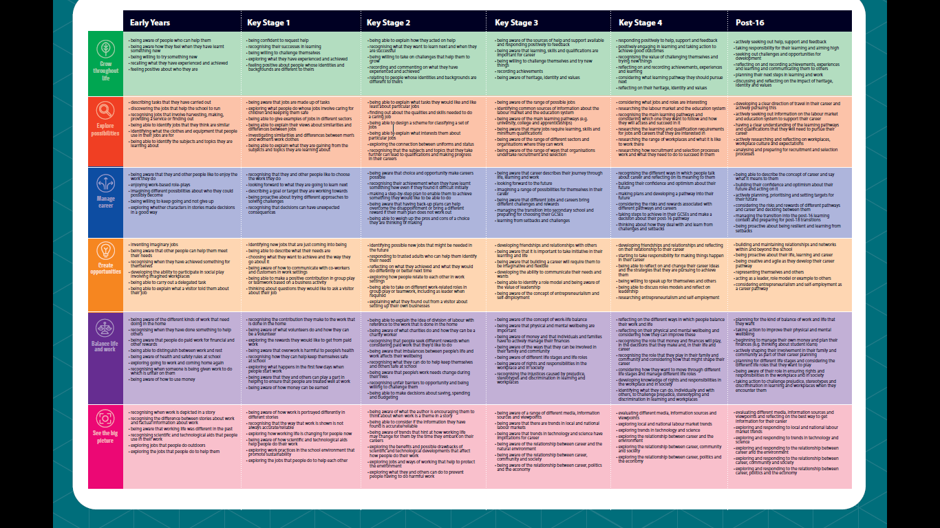
CDI Framework to Key Stage 3

 | AQA Unit Award Scheme | CDI Framework Strand
Module 1 | Self Awareness 70042 | KS3 Grow Throughout Life
Module 2 | Making Informed Career Choices 13020 | KS3 Explore Possibilities, Manage Career and See the Big Picture
Module 3 | Employability: Why Work? 114314 | KS3 Manage Career, Balance life and Work and Create Opportunities
Module 4 | Recognising work areas in the local community 70157 | KS3 Create Opportunities, Explore Possibilities, Manage Career, Balance work and life and See the big picture
Module 5 | Investigating possible career options 115325 | KS3 Manage Career, Explore Possibilities and Create Opportunities
Module 6 | Engaging with the careers service 105360 | KS3 Grow throughout Life, Explore Possibilities, Manage Career, Create Opportunities and See the Big Picture
Enterprise Module | Pop-Up Enterprise 120032 | KS3 Create Opportunities
Key Stage 3+ Incredible Futures Careers Curriculum

AQA Unit Award Scheme Modules

