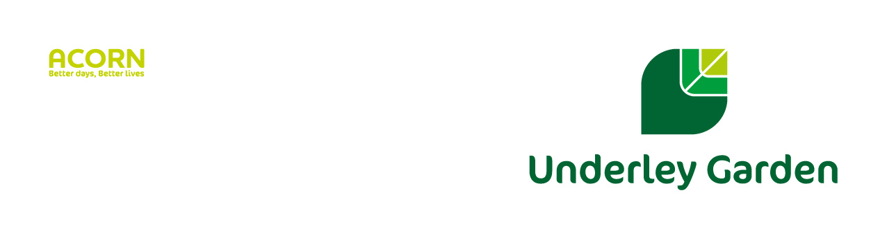

**School Term and Holiday Dates**

**2025/26**

|  |  |
| --- | --- |
| **Autumn Term 2025** | |
| Term starts | Tuesday 2nd September |
| Mid term closure | Monday 20th October - Friday 31st October (2 weeks) |
| End of term | Friday 19th December |
| Number of openings | 69 |

|  |  |
| --- | --- |
| **Spring Term 2026** | |
| Term starts | Tuesday 6th January |
| Mid term closure | Monday 16th February - Friday 20th February (1 week) |
| End of term | Friday 27th March |
| Number of openings | 54 |
| **Summer Term 2026** | |
| Term starts | Tuesday 14th April |
| May Day Bank Holiday | Monday 4th May (**School will be closed**) |
| Mid term closure | Monday 25th May - Friday 29th May (1 week) |
| End of term | Thursday 23rd July |
| Number of openings | 67 |
| Total number of openings | 190 days |

**INSET Days**

Day 1: Monday 1st September

Day 2: Monday 5th January

Day 3: Monday 13th April

Day 4: Friday 24th July

**Public Holidays in England 2025/2026**

**The below dates are mostly within the school holidays:**

25 August 2025 - August Bank Holiday

25 December 2025 - Christmas Day

26 December 2025 - Boxing Day

1 January 2026 - New Year’s Day

3 April 2026 - Good Friday

6 April 2026 - Easter Monday

4 May 2026 - Early May Bank Holiday

25 May 2026 – Spring Bank Holiday

**Dates for the diary (specific dates & times TBC)**

17th December - Christmas Fayre and parents evening 4-6pm

25th March - ‘Illuminating Imaginations’ and parents evening 4-6pm

Week Beginning 26th June - Sports Day, exact date TBC

22nd July - Summer Ball & parents evening 4-6pm