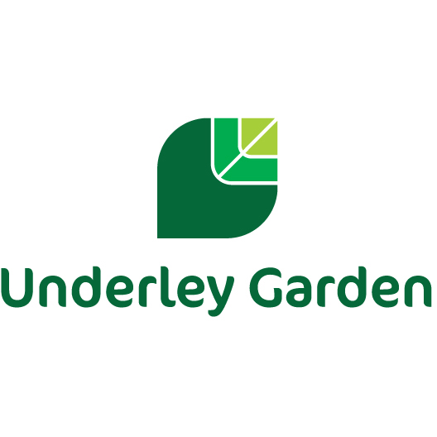**Exam Results – 2023-2024**

|  |  |  |  |  |  |  |  |  |  |
| --- | --- | --- | --- | --- | --- | --- | --- | --- | --- |
| GCSE Results | Pupils Entered | Grade 8 | Grade 7 | Grade 6 | Grade 5 | Grade 4 | Grade 3 | Grade 2 | Grade 1 |
| English Language | 2 |  |  |  |  |  |  | 2 |  |
| English Literature | 2 |  |  |  |  |  |  | 1 | 1 |

|  |  |  |  |
| --- | --- | --- | --- |
| Functional Skills Subject Results | Pupils Entered | Pass | Fail |
| Mathematics (Level 1) | 2 | 2 |  |
| Mathematics (Level 2) | 3 | 2 | 1 |
| English – Reading and Writing (Level 1) | 4 | 4 |  |
| English – Reading and Writing (Level 2) | 2 |  | 2 |

|  |  |  |  |  |
| --- | --- | --- | --- | --- |
| Portfolio Based Accreditation Results | Pupils Entered | Level 1 | Level 2 | Level 3 |
| Geography - ELC | 3 |  |  | 3 |
| History – ELC | 3 |  | 1 | 2 |
| Science Double Award - ELC | 3 |  | 3 |  |
| Step up to English (Silver) - ELC | 6 | 2 | 4 |  |
| Step up to English (Gold) - ELC | 2 |  |  | 2 |
| Mathematics – ELC | 3 |  | 3 |  |
| NCFE Level 2 Technical Award in Health and Fitness | 3 | 1 |  |  |

|  |  |
| --- | --- |
| Open Awards | |
| Entry Level 1 Certificate in skills for further learning and employment | 4 |
| Entry Level 1 Diploma in skills for further learning and employment | 7 |
| Entry Level 3 Certificate in Independent living-living in the community | 2 |
| Entry Level 3 Extended Certificate in skills for further learning and employment | 1 |
| Entry Level 3 Diploma in skills for further learning and employment | 3 |
| Level 1 Certificate in skills for further learning and employment (SFLE) | 3 |