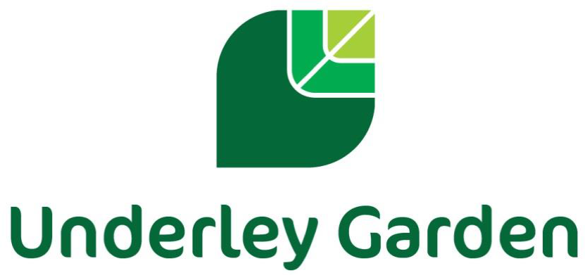

Careers Policy

Created: | 2018
Reviewed by: | Rochelle Sowden (Careers Lead)
Reviewed: | Sept 2023
To be reviewed: | Sept 2024

Introduction

Underley Garden School is an independent school providing specialist education for children and young
people aged 5 – 19 with a range of Complex Needs. All of our children and young people have significant barriers to learning due to their complex learning difficulties and disabilities in the area of autistic spectrum conditions, moderate to severe learning difficulties, associated medical and health issues and moderate mental health conditions. All of our young people are extremely vulnerable and many have experienced disruption to formal education.

At Underley Garden School, we believe all young people deserve the right to an education that will
support them to become happy and confident individuals with skills, qualifications and achievements
that will support them in their future. The overriding aim of our curriculum and wider work is to achieve the best possible outcomes for our young people in terms of individual learning, independence, personal growth and development and preparation for the world of work. We believe that a robust Careers program and guidance provides a major contribution in supporting them in choosing appropriate pathways that suit their interests, needs and abilities and help them to follow an appropriate career path and sustain employability throughout their working lives where possible.

At Underley Garden, the Career Development Institute (CDI) framework is the foundation of our Careers curriculum up to, and including, Key Stage 3. From Key Stage 4 our young people access Princes Trust qualifications as well as following the Gatsby Benchmarks as part of the DfE Careers Strategy. (See appendix 1 and 2 for more details)

Rationale

Underley Garden offers a broad and balanced curriculum and aims to provide Careers Guidance that:
    - Is accurate and up to date
    - Is presented in an impartial manner
    - Contributes to strategies for raising achievement, especially by increasing motivation and providing access to accreditation pathways
    - Supports inclusion, challenge stereotyping and promote equality of opportunity
    - Develops enterprise and employment skills
    - Contributes to the economic prosperity of individuals and communities
    - Meets the needs of all our young people through appropriate differentiation
    - Focuses on young people on their future aspirations
    - Involves parents and carers

At Underley Garden, we recognise and celebrate that all of our young people are different and as a result, their education and career pathways will be planned on an individualised basis, we use a holistic, person-centered approach to the development of our young people to ensure they achieve the best possible outcomes. Although we follow the CDI framework that is organised into key stages, our Careers curriculum is flexible and key stages are followed depending on the individual needs and main areas of development within that class, as opposed to their age group. The Princes Trust Qualification support our delivery of careers education across Key stage 4 and above. The qualification is offered at Entry 3, Level 1 and Level 2 and can be completed in a timescale that suits our young people’s pace of learning. We believe careers education should start as early as possible and so we ensure it is incorporated into the curriculum from reception upwards.

Underley Garden aims to maximise the benefits for every young person, supporting them to reach their full potential and give a sense of direction in their future life. The young people will access the possibilities and opportunities available to them in the world of work through work related learning opportunities both onsite and offsite where possible.
We aim to equip our young people with skills for working life by promoting personal development, functional skills and independence skills; which in turn will support to improve motivation and attainment, self-esteem and developing long term realistic aspirations. Thus, preparing them for adulthood and working life.

Student Entitlement

Careers Education and guidance is an important component of the Curriculum and at Underley Garden, we fully support the statutory requirement for a programme of careers education. Young people have access to a careers programme that is delivered as a stand-alone lesson within the weekly timetable for young people following our Daisy and Sunflower pathways. For students following our Bluebell pathway or who are below KS3, Careers is delivered as part of a thematic approach and is very much individualised to each student’s needs (Please see our curriculum policy for further details of our learning pathways). Our careers curriculum gives young people the opportunity to explore a range of careers possibilities, qualifications routes and learning paths. We hold an annual Careers week, liaising with a wide array of local businesses who deliver employer engagement opportunities and workshops to support our young people’s interests. Our young people also have opportunities for 1:1 careers meetings with our independent careers advisor, who schedules regular visits to our school. Where appropriate the Careers advisor attends EHCP reviews, Child looked after meetings and Personal educational planning meetings. Young people in KS4 and 5 are given the opportunity to attend off site careers events and college open evenings / events and work skill placements. Transition visits to other training providers are also supported so young people are aware of as many options available to them as possible. Where a student’s next steps is to attend a provision in a different local authority, links will be made at the earliest opportunity with the relevant people and organisations to ensure a smooth transition.

Implementation of Careers Education and advice

Careers education is delivered to all young people and provision is made to allow all young people to access the curriculum at the appropriate level. Young people are encouraged to follow career paths that suit their interests, skills and strengths with the absence of stereotypes. At Underley Garden, the CDI framework is the foundation of our Careers curriculum up to, and including Key stage3. From Key Stage 4, our young people will be enrolled to complete units for The Princes Trust Personal Development and employability qualification as well as following the Gatsby Benchmarks as part of the DfE Careers Strategy. There are six learning areas within the CDI framework that can be seen below. These are incorporated into our whole school curriculum map, one area being covered each half term.
Learners can be enrolled onto a choice of an Award, Certificate, Extended Certificate or a Diploma
Qualification from The Princes Trust.

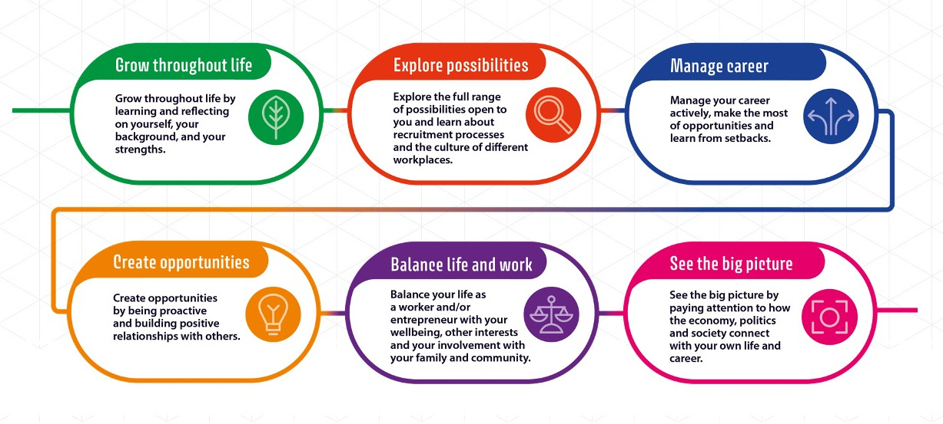

See appendix 2 for more details

The young people at Underley Garden also have access to an Independent Careers advisor from Inspira as well as an allocated Outcomes First Group Apprenticeship, Careers and employability advisor. The career advisors support our young people with appropriate and up to date good quality personal guidance with clear links to labour market opportunities.

‘A ‘positive career’ will mean something different to different people, but it will typically include being happy with the way you spend your time, being able to make a contribution to your community and being able to have a decent standard of living’. (CDI framework 2021)

Assessment

Assessment is integral to teaching and learning within Careers and is carried out in accordance with the whole-school policy. We use the CDI Framework to help track our young people’s progress in Careers, up to Key Stage 3, and identify areas of development. Our assessment is ongoing and is continually captured throughout the school day when our pupils are seen applying their skills and knowledge in real-life situations or to different subjects using Evidence for Learning. The style of assessment used is non-threatening and promotes the young people’s self-esteem. There are clearly defined links between objectives and assessment. The criteria by which the work is to be judged are shared and accessible by the young people, where appropriate. Assessment is continuous and the outcomes of the process are used to inform subsequent teaching. Young people receive regular feedback from their teachers concerning their progress and achievement and this is communicated to parents, carers and associated professionals in termly subject reports and in the statutory annual review documentation. The Princes Trust qualification is assessed by our trained careers advisor to ensure they have met criteria to gain the appropriate qualification. The assessment process for Princes Trust is as follows:
Activities are internally set by the centre to meet the requirements detailed in the unit assessment criteria
- The learners are assessed internally at the centre by an Assessor whilst they engage in activities
- The learner’s evidence is collated into a portfolio, which is referenced using a unit Tracking Sheet
- The centre undertakes internal quality assurance activities which includes sampling portfolios assessed by each Assessor.
- A further sample of portfolios is then externally moderated by Prince’s Trust Qualifications

Post 16

Our Post 16 provision offers a semi-formal curriculum with a holistic approach that focuses on developing Independent Life skills, Personal development and Preparing for Adulthood.

We provide a variety of vocational options that have been developed to give learners the opportunity to:
  - Experience more than one vocational sector where they have not yet decided on a specific sector to follow
  - Develop knowledge, understanding and skills of difference vocational sectors to motivate them to progress to higher-level qualifications or employment in a specific sector.
  - Develop cross-cutting employability skills through carrying out practical activities in a vocational context
  - Engage in learning which is relevant to them and provide opportunities to develop a range of skills and techniques, personal skills and attributes essential for successful performance in working life
  - Progress to employment, further education, volunteering or training

Accreditation Opportunities

Careers Education, Personal development and Work Related Learning is well promoted throughout the curriculum and accredited in Post 16, there are several accredited courses including:

- Open Awards Entry level Award, Certificate and Diploma in Skill for further learning and Employment
- Open Awards Entry level Award and Certificate in Independent Living-Looking After Yourself and your Home
- Open Awards Entry level Award and Certificate in Independent Living-Living in the Community
- Princes Trust Personal Development and employability qualification

These courses enables learners to gain knowledge, skills and experience in:
- Developing Self
- Preparation for Work
- Managing Own Money
- Career Progression
- Financial Capability
- Skills for Employment
- Opportunities for Learning and Work
- Keeping safe in the community
- Experiencing the world of work
- Wellbeing

Work Experience

Aim of Work Experience:

- To enable the development and learning of young people
- To provide young people with records/documents to provide evidence of their experience
- To provide young people with direct experience of the world of work
- To give young people the experience of relationships, routines and processes that are part of a working environment
- To develop work related skills
- To contribute towards approved vocational and academic qualifications where necessary
- To prepare young people for adult and working life
- To encourage young people to widen their horizons by viewing work experience as an opportunity to sample non-traditional areas of work
- To prepare young people by discussing equal opportunities
- To make clear the roles and responsibilities of all involved in work experience
- Work experience can provide an excellent opportunity for young people to develop an understanding of what an employer will expect of them and so enhance their employability.
- Various patterns and length of work experience placements need to be flexible to ensure that the learning needs of our young people are met.
- The work will be appropriate to the student’s capabilities.
- There will be an appropriate level of supervision provided throughout the placement.
- Placements are assessed for risks and insurance checked.

Supporting Young People on Work Experience

WORK EXPERIENCE COMMENCES

STUDENT
PLACEMENT

SCHOOL

VISITS BY CAREERS
ADVISOR CO-OPERATE WITH EMPLOYER INDUCTION
SUITABILITY WEAR PROTECTIVE EQUIPMENT SUPERVISION
EXPECTATIONS KEEP A DIARY SAFE ENVIRONMENT
H&S INDUCTION DISCUSS PROGRESS
EMERGENCY CONTACTS
SUPERVISION

EVALUATION

Parents and Carers

Parental involvement is important and encouraged at all stages. Parents / carers are kept up to date with careers related information through Newsletters and our Website. They are also updated during parents’ evenings and within school reports. Regular updates are also given during annual reviews (Inc. EHCP, PEP, and CLA’s)

Monitoring

The practical application of this policy will be reviewed annually or when the needs arise. If you have any questions or queries with regards to this policy or our Careers curriculum please contact the careers lead on the information below:
Rochelle Sowden
Tel: 01524 271569
Email: rochelle.sowden@underleygarden.org

Appendix 1.

The Gatsby Benchmarks are:

1. A stable careers programme | Every school and college should have an embedded programme of career education and guidance that is known and understood by young people, parents, teachers, governors and employers. | Every school should have a stable, structured careers programme that has the explicit backing of the senior management team, and has an identified and appropriately trained person responsible for it.  The careers programme should be published on the school’s website in a way that enables young people, parents, teachers and employers to access and understand it.  The programme should be regularly evaluated with feedback from young people, parents, teachers and employers as part of the evaluation process.
2.Learning from career and labour market information | Every student, and their parents, should have access to good quality information about future study options and labour market opportunities. They will need the support of an informed adviser to make best use of available information. | By the age of 14, all young people should have accessed and used information about career paths and the labour market to inform their own decisions on study options.  Parents should be encouraged to access and use information about labour markets and future study options to inform their support to their young people.
3.Addressing the needs of each student | Young people have different career guidance needs at different stages. Opportunities for advice and support need to be tailored to the needs of each student. A school’s careers programme should embed equality and diversity considerations throughout. | A school’s careers programme should actively seek to challenge stereotypical thinking and raise aspirations.  Schools should keep systematic records of the individual advice given to each pupil, and subsequent agreed decisions.  All young people should have access to these records to support their career development.  Schools should collect and maintain accurate data for each pupil on their education, training or employment destinations.
4.Linking curriculum learning to careers | All teachers should link curriculum learning with careers. STEM subject teachers should highlight the relevance of STEM subjects for a wide range of future career paths. | By the age of 14, every pupil should have had the opportunity to learn how the different STEM subjects help people to gain entry to, and be more effective workers within, a wide range of careers.
5.Encounters with employers and employees | Every student should have multiple opportunities to learn from employers about work, employment and the skills that are valued in the workplace. This can be through a range of enrichment activities including visiting speakers, mentoring and enterprise schemes. | Every year, from the age of 11, young people should participate in at least one meaningful encounter* with an employer.  *A ‘meaningful encounter’ is one in which the student has an opportunity to learn about what work is like or what it takes to be successful in the workplace.
6.Experiences of workplaces | Every student should have first-hand experiences of the workplace through work visits, work shadowing and/or work experience to help their exploration of career opportunities, and expand their networks. | By the age of 16, every pupil should have had at least one experience of a workplace, additional to any part-time jobs they may have.  By the age of 18, every pupil should have had one further such experience, additional to any part-time jobs they may have.
7.Encounters with further and higher education | All young people should understand the full range of learning opportunities that are available to them. This includes both academic and vocational routes and learning in schools, colleges, universities and in the workplace. | By the age of 16, every pupil should have had a meaningful encounter* with providers of the full range of learning opportunities, including Sixth Forms, colleges, universities and apprenticeship providers. This should include the opportunity to meet both staff and young people.  By the age of 18, all young people who are considering applying for University should have had at least two visits to universities to meet staff and young people.  *A ‘meaningful encounter’ is one in which the student has an opportunity to explore what it is like to learn in that environment.
8.Personal guidance | Every student should have opportunities for guidance interviews with a career adviser, who could be internal (a member of school staff) or external, provided they are trained to an appropriate level. These should be available whenever significant study or career choices are being made. | Every pupil should have at least one such interview by the age of 16, and the opportunity for a further interview by the age of 18

Appendix 2.

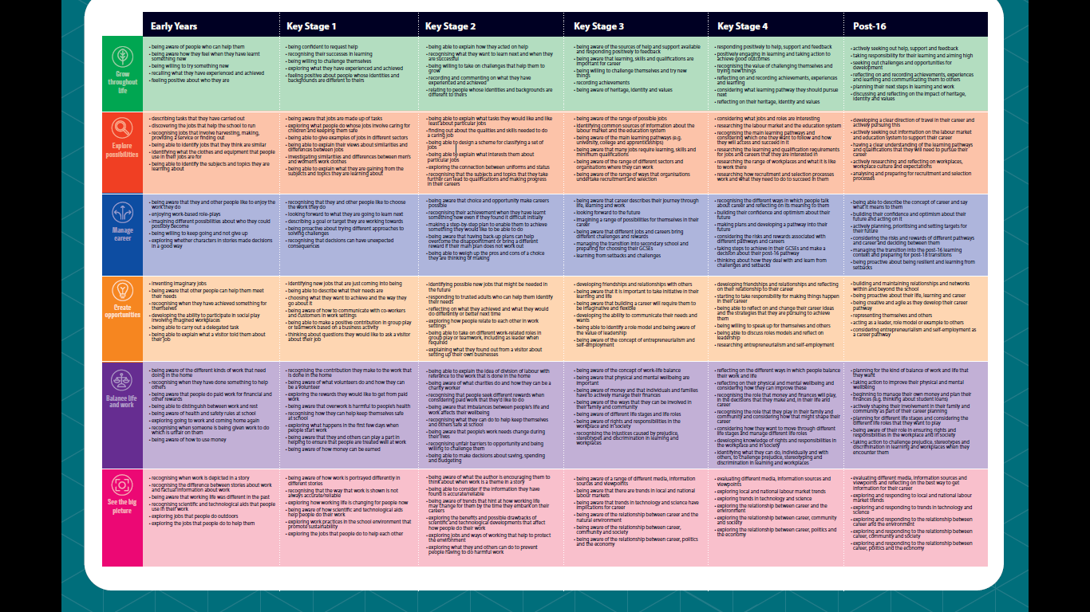
CDI Framework to Key Stage 3

Appendix 3

Princes Trust Personal Development and employability qualification units

